Lab Report on University Payroll Management System
1. Introduction
Payroll management is an essential administrative task in any university or large organization. Managing employee information, calculating salaries, applying allowances and deductions, and generating salary reports manually is time-consuming and error-prone.
This laboratory project focuses on developing a University Payroll Management System that automates payroll processing using modern software engineering principles. The system is designed with a backend service for handling data and business logic, and a frontend interface that allows administrators to interact with the system easily.
2. Objectives
The main objectives of this project are:
- To design a payroll system using object-oriented programming principles
- To manage employee records efficiently
- To prevent duplicate salary payment for the same month
- To calculate salary including allowances and deductions
- To generate monthly payroll summaries and salary receipts
- To develop a simple and user-friendly frontend interface
3. System Overview
The system follows a client–server architecture:
- The backend is responsible for storing employee and payroll data, applying salary rules, and exposing APIs.
- The frontend acts as an administrative dashboard through which users can perform payroll-related operations.
The system supports multiple types of employees such as teachers, officers, and staff. Salary is calculated based on basic salary along with predefined allowances and deductions.
4. Functional Features
The major features implemented in the system are:
- Employee Management
  - Add new employees
  - View employee list
  - Soft delete employees (inactive but preserved in database)
- Payroll Processing
  - Pay salary for a selected month and year
  - Ensure that a salary for the same employee cannot be paid twice in the same month
- Reports and Visualization
  - Monthly payroll summary
  - Salary receipt for individual employees
  - Dashboard visualizations (employee distribution, monthly expense)
5. Business Rules Applied
The system enforces the following payroll rule:
- A month’s salary cannot be paid more than once for the same employee
This rule ensures data integrity and prevents duplicate payroll entries.
6. User Interface Description
The frontend provides a clean dashboard-style interface with a sidebar for navigation. Through this interface, an administrator can:
- Add employees
- View and manage employee records
- Pay salaries
- View payroll summaries
- Generate salary receipts
Visual elements such as charts and metrics are used to make the system more informative and easier to understand.
7. Software Interface and processes:
1. Home Page: Home page of the software has employee count and their distribution by various category.
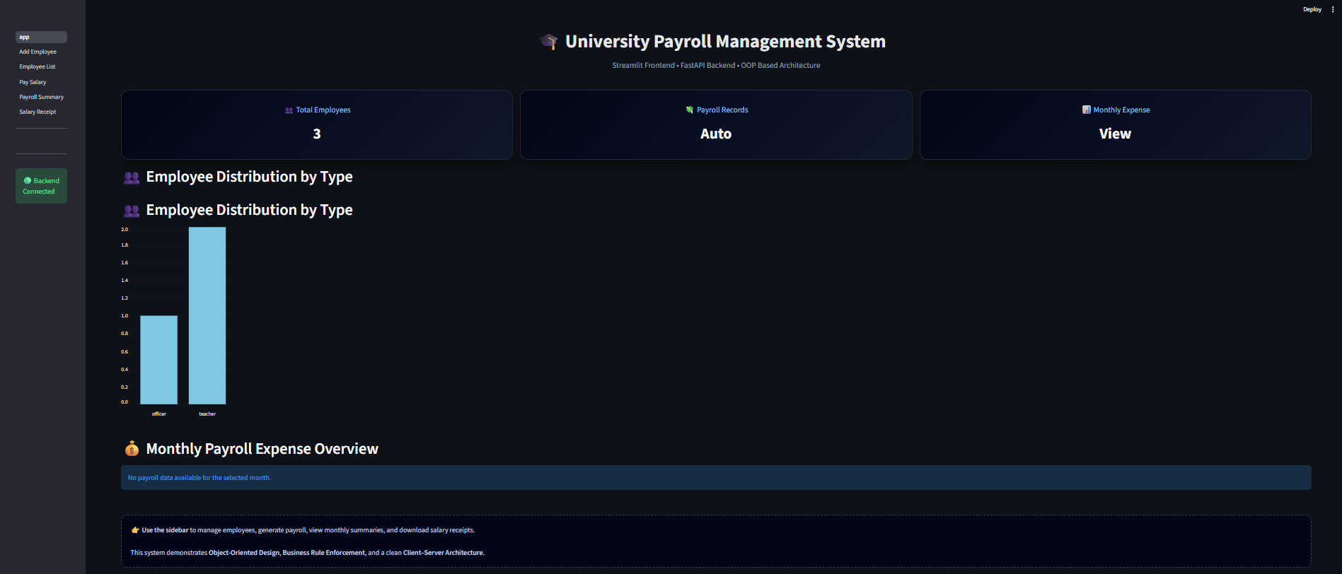
Figure 01: Home Page
2. Add Employee: Add employee page contains a form regarding the information of the employee. Which includes Employee type, Full Name, Employee Age, Email address, Phone Number, Designation, Faculty, Department and Basic Salary.
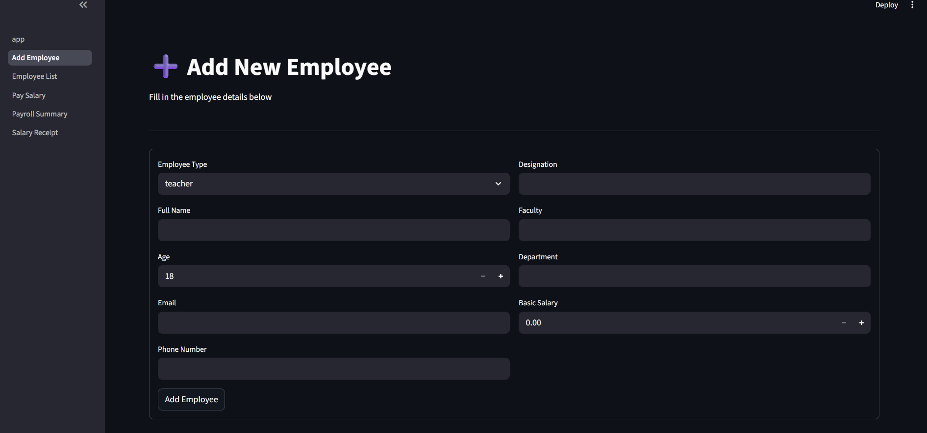
Figure 02: Add New Employee Form
3. Employee list: Employee List page shows the list of the current employees including their id, name, type, age, designation, Faculty, Department and Base Salary
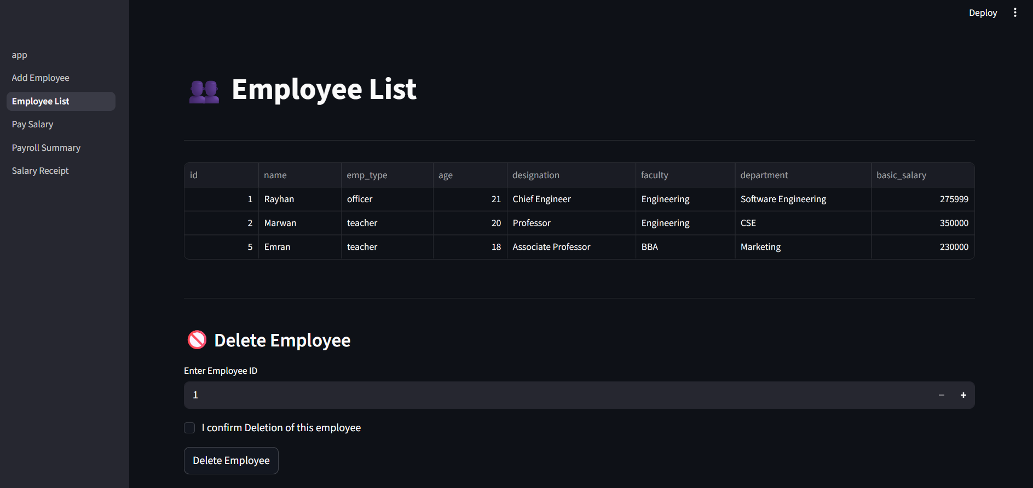
Figure 03: Employee List And Employee Deletion Page

4. Pay Monthly Salary: This page gives admin to pay the salary of all the employees for a particular year and month. Salary of a single month can not be given twice.
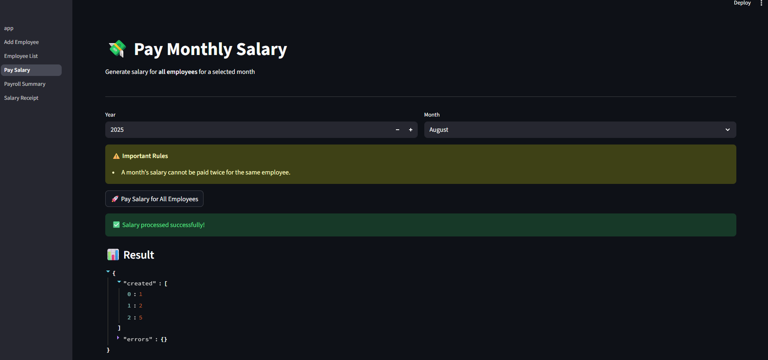
Figure 04: Pay Monthly Salary of the Employees

5. Payroll Summary: This page shows a report of the monthly summary of payments of all employees. This page also has important feature to filter the pay summary based on the Faculty, Department or Designation of the employees
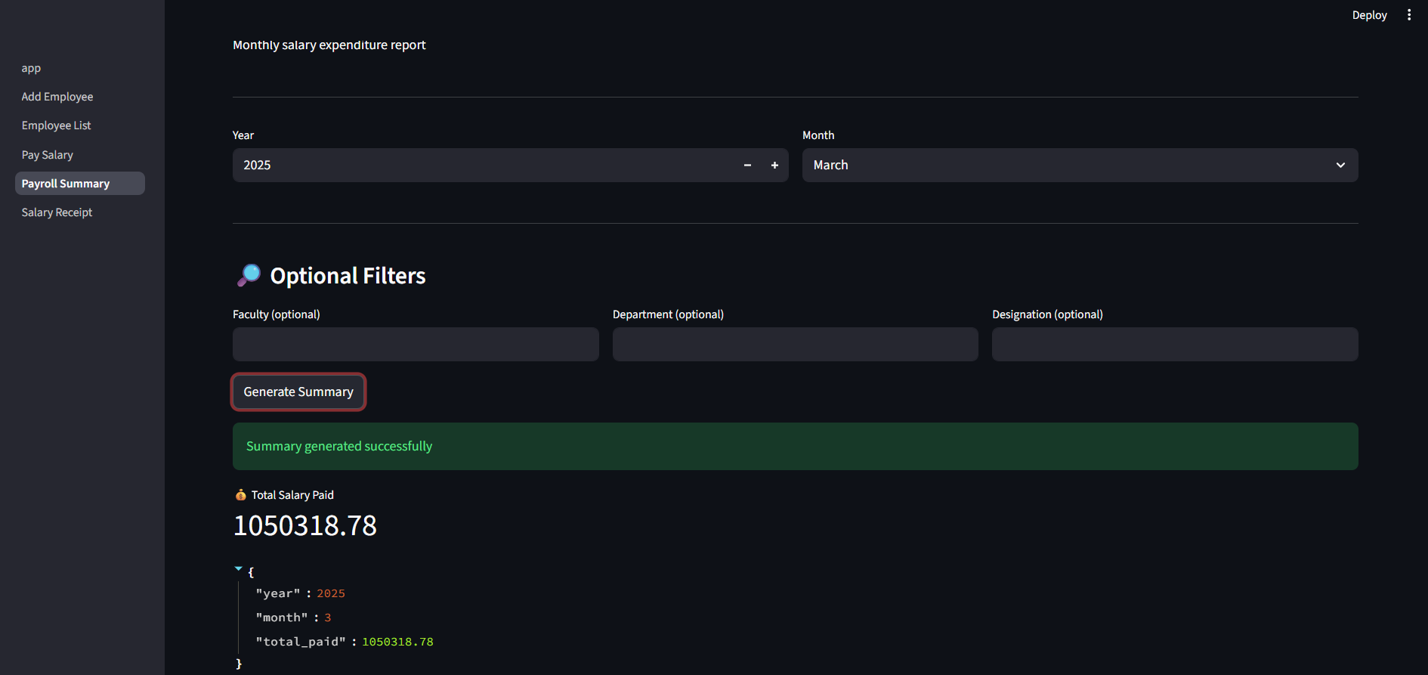
Figure 05: Payroll Summary With Filters on Employees
6. Salary Receipt: This Page provide option for the user to generate a salary receipt for each employee by giving input of the employee id and selected month of a year. The Salary receipt includes Basic Information of the employee, the base salary of the employee, with all kinds of allowances and deductions, and Finally the Net Salary of the selected employee.

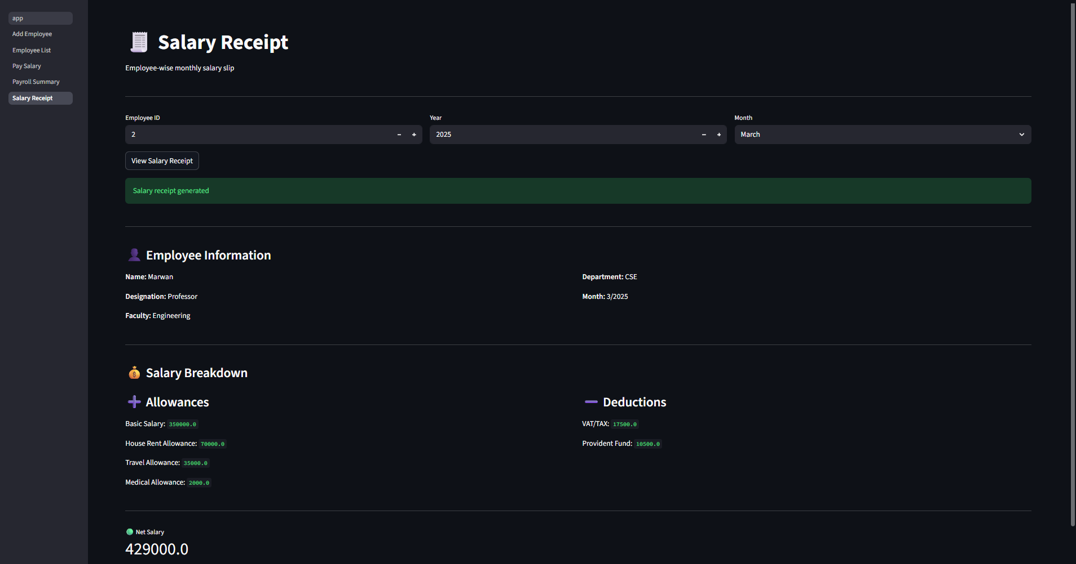
Figure 06: Salary Receipt of the Employee

8. Testing and Validation
The system was tested by:
- Adding multiple employees
- Paying salary for different months
- Verifying that duplicate salary payment is blocked
- Checking correctness of payroll summary and salary receipt
- Validating frontend-backend communication
All major functionalities worked as expected during testing.
9. Conclusion
This project successfully demonstrates the implementation of a payroll management system using modern software development techniques. It integrates backend logic with a frontend interface and applies essential business rules to ensure correctness. The project fulfills all academic requirements of a software engineering lab and provides a solid foundation for further extension into a full-scale payroll application.

